

Data Technician

Name:
Course Date:
Table of contents
Day 1: Task 1 3
Day 1: Task 2 3
Day 1: Task 3 4
Day 2: Task 1 5
Day 3: Task 1 9
Day 3: Task 2 10
Day 3: Task 3 11
Day 4: Task 1 12
Day 4: Task 2 13
1. Scenario Background 13
2. Data Laws and Regulations 14
3. Azure Service Recommendations 14
4. Data Types and Data Modelling 14
5. Data Storage Formats and Structures in Azure 14
6. Additional Considerations 15
Submission Guidelines: 15
Course Notes 17
Additional Information 17

Day 1: Task 1
Please research and complete the below questions relating to key concepts of cloud.
Be prepared to discuss the below in the group following this task.
What can cloud computing do for us in the real-world? | Cloud computing provides greater flexibility, efficiency and strategic value by enabling organizations to use IT infrastructure and applications over the internet instead of installing and maintaining them on-premises. Within a business sense, the most common tool that leverages this would the use of Virtual machines, which leverage the cloud to run infrastructure and other business resources (Susnjara, S. and Smalley, I., 2025).
How can it benefit a business? | Businesses can benefit from cloud computing by having their resources and infrastructure in cloud, and not on-premises, as on-premises infrastructure in high volumes, such as storage is expensive, whereas cloud computing services are relatively inexpensive. In addition, it is also beneficial for businesses to maintain their scalability - businesses can grow and scale alongside their cloud infrastructure.
What’s the alternative to cloud computing? | Ideally, there are only two approaches to incorporating cloud computing: doing so or not doing so. However, there are a few "middle ground" methods that aim to maximize the strengths of both approaches.  A company may wish to pursue:  - Edge Computing: a distributed architecture, where the infrastructure is also close to the resources as possible, to decrease latency (increase response times).  - Mesh Computing: a non-hierarchical network design, where the aim is to also decrease latency, but to also allow to also increase the network coverage of systems, internally.  - Colocation Hosting: a data-centre service, where clients rent physical and/or intangible hardware, which allow for more accurate data monitoring, and allows for control over storage; distributed data (Marijan, B., 2025).
What cloud providers can we use, what are their features and functions? | 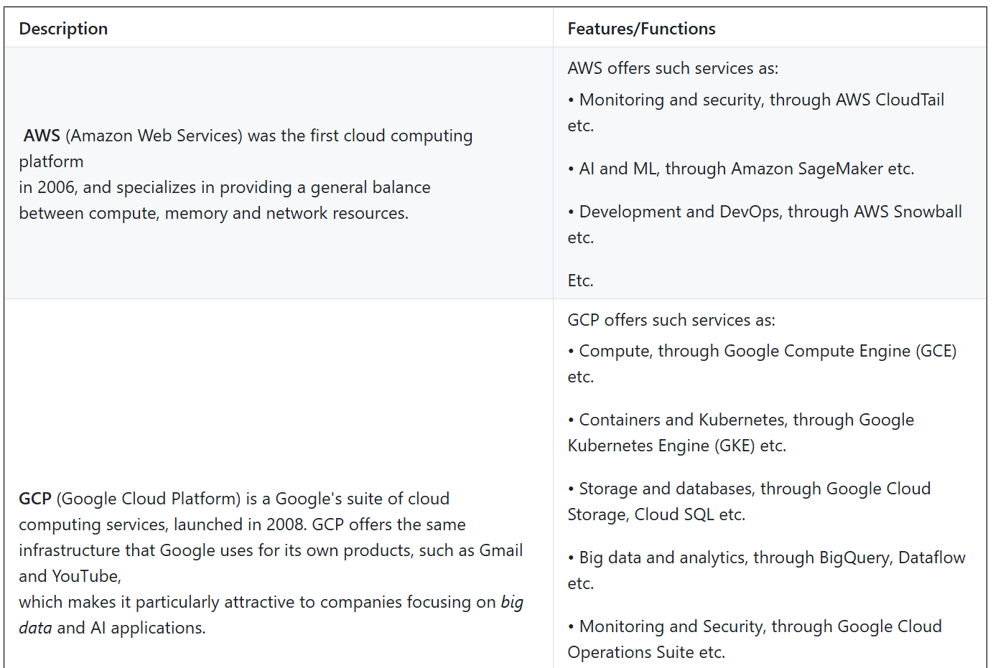  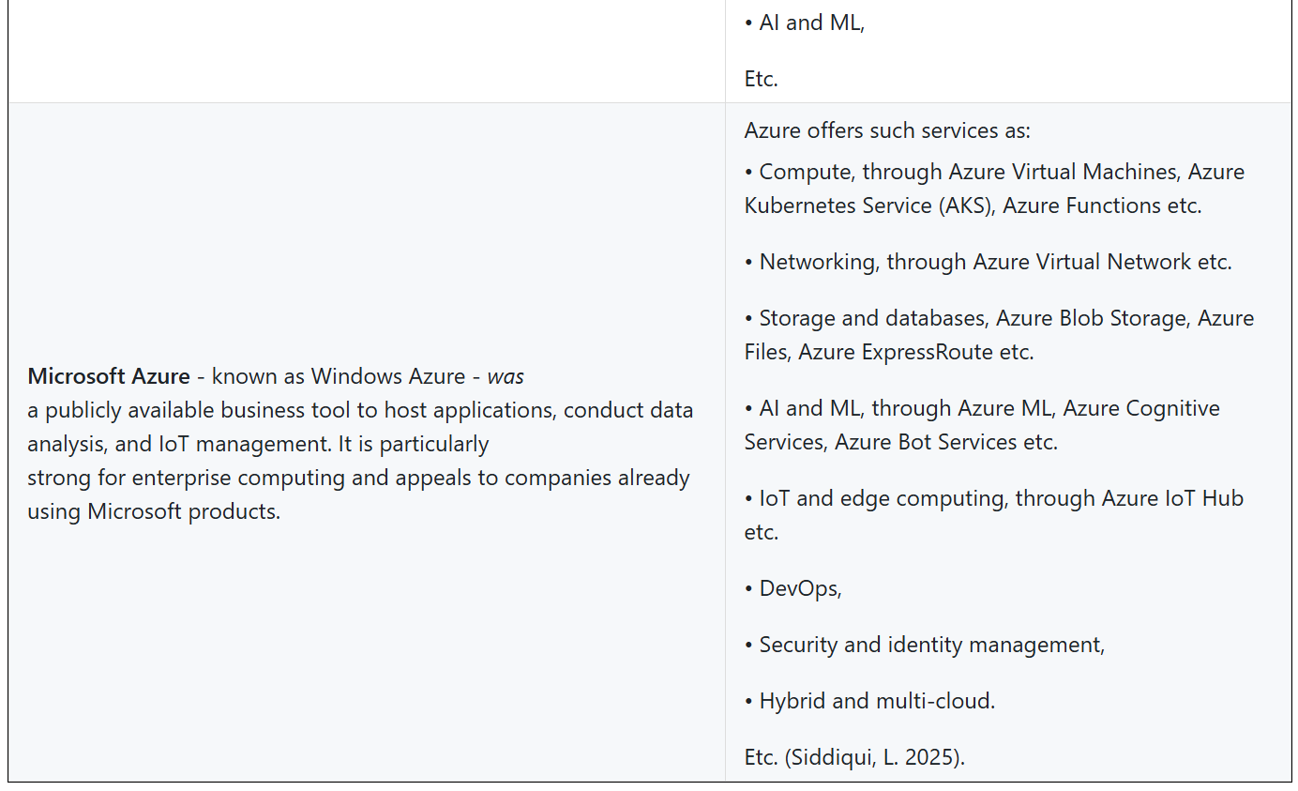

References
Marijan, B. (2025) Alternatives to Cloud Computing - 6 Options Explained [blog post]. phoenixNAP, 20 October. Available from: https://phoenixnap.com/blog/alternatives-to-cloud-computing [Accessed: 18 December, 2025].
Siddiqui, L. (2025) AWS vs. Azure vs. Google Cloud: A Complete Comparison [blog post]. DataCamp, 19 February. Available from: https://www.datacamp.com/blog/aws-vs-azure-vs-gcp [Accessed: 18 December, 2025].
Susnjara, S. and Smalley, I. (2025) What are the benefits of cloud computing? [blog post]. IBM, 17 November. Available from: https://www.ibm.com/think/topics/cloud-computing-benefits [Accessed: 18 December, 2025].

Day 1: Task 2
Please research the below cloud offerings, explain what they are and examples of use cases.
Cloud Offerings | Explain what it is | When / how might you use this service in the real-world?
IaaS (Infrastructure as a service) | Infrastructure as a Service (IaaS) is a form of cloud computing that delivers IT infrastructure resources such as services, virtual machines (VMs), compute, network and storage to clients over the internet and on a pay-as-you-go basis (Susnjara, S. and Smalley, I., 2025). | The IaaS cloud model represents general-purpose compute resources and can thus support use cases of all types. IaaS provides cloud-bases backup and disaster recovery solutions, allowing organizations to replicate and back up their systems and data in the cloud. If one server fails, another takes over, helping ensure business continuity (Susnjara, S. and Smalley, I., 2025b).
PaaS (Platform as a service) | Platform as a Service (PaaS) is a cloud computing model that provides a complete on-demand cloud platform - hardware, software and infrastructure - for developing, running and managing applications. The PaaS provide hosts everything - servers, networks, storage, operating system software, databases and development tools - at their data centre. Typically, clients can pay a fixed fee to provide a specified amount of resources for a specified number of users, or they can choose "pay-as-you-go" pricing to pay only for the resources you need (Susnjara, S. and Smalley, I., 2025b). | PaaS provides an integrated and ready-to-use platform and enables organizations to offload infrastructure management to the cloud provider. This allows development teams to focus on building, deploying and managing applications. PaaS can ease or advance several IT initiatives, such as providing support a range of programming languages (for example, Java, Python, Swift and more), tools and application environments used for Internet of Things (IoT) application development and real-time processing of data generated by IoT devices (Susnjara, S. and Smalley, I., 2025b).
SaaS (Software as a service) | Software as a Service (SaaS) is a cloud-based software delivery model in which providers host applications and make them available to users over the internet. SaaS users typically access applications by using a web browser or app. The SaaS provider is responsible for operating, managing and maintaining the software and the infrastructure on which it runs.  The customer simply creates an account, pays a fee and access the software.  All SaaS applications share these characteristics:  - SaaS applications are built to be hosted on the cloud: SaaS software vendors can host applications on their own cloud infrastructure or with a cloud service provider.  - SaaS applications are accessible to any customer  with an internet connection and an internet-connected user device: SaaS applications typically run in any web browser and on any computer or mobile device, but they often run more effectively on mobile phones and/or tablets.  In some instances, SaaS applications can offer or require a dedicated thin client, a lightweight computing device  that runs remotely on resources stored on a central server.  - SaaS applications use multi-tenant architecture, where a single instance of a software application (and its underlying database and hardware) serves multiple tenants (or user accounts). To maintain data security and privacy, each tenant's application data, user data, system data and custom configurations are segregated from those of other customers.  - SaaS applications require little to no management and zero maintenance from the customer: The SaaS vendor is responsible for provisioning, managing and maintaining all the servers and infrastructure required to run the application, and for applying feature upgrades and security patches when necessary. They provide load balancing and data backup features, infrastructure redundancies, and disaster recovery services to prevent outages and meet Service Level Agreements (SLAs) (China, C.R., 2025). | An all too familiar example of the SaaS would be Zoom - Zoom emerged as a dominant SaaS platform for video conferencing and webinars. Its user-friendly interface and reliable performance have made it a household, or office space, name during and before the pandemic. As a result, businesses can use Zoom to conduct virtual team meetings, transcending geographical barriers and enabling effective communication (Aalpha information Systems India Pvt Ltd, 2023).

References
Aalpha information Systems India Pvt Ltd (2023) 10 Examples of SaaS With Use Cases [blog post]. LinkedIn, 27 July. Available from: https://www.linkedin.com/pulse/10-examples-saas-use-cases-aalphaindia [Accessed: 19 December, 2025].
China, C.R. (2025) What is Software as a Service (SaaS)? [online]. IBM. Available from: https://www.ibm.com/think/topics/saas [Accessed: 19 December, 2025].
Susnjara, S. and Smalley, I. (2025) What is Infrastructure as a Service (IaaS)? [online]. IBM. Available from: https://www.ibm.com/think/topics/iaas [Accessed: 19 December, 2025].
Susnjara, S. and Smalley, I. (2025b) What is Platform as a Service (PaaS)? [online]. IBM. Available from: https://www.ibm.com/think/topics/paas [Accessed: 19 December, 2025].

Day 1: Task 3
Please research the below terms and explain what they are, when they would be appropriate and a real-world example of where it could be implemented (i.e. what type of organisation).
Public Cloud | A Public Cloud is a cloud computing model in which third-party providers deliver computing  resources, over the internet to multiple clients on a shared infrastructure. It operates on a pay-as-you-go model, allowing businesses and cost-effective IT services without the need for on-premises hardware. Public cloud services are managed, maintained, and secured by third-party providers, who aim to deliver high availability, reliability, and continuous updates. This model allows organizations to scale resources on demand, enhance flexibility and leverage advanced technologies without the complexity of managing physical infrastructure (Microsoft, n.d.).  Example  An example of this model is used in the healthcare industry, the sharing and exchange of highly sensitive health data tied to personally identifiable information (PII). Because of this, it's important to work with public cloud providers that offer specialized healthcare clouds or vertical clouds that are HIPPA-compliant and meet any other stringent regulations for workloads that require more security. This connection has the potential to cut down on time to diagnosis, plan for better treatments, and even save lives (Pacheco, M., 2023).
Private Cloud | A private cloud is a cloud computing environment dedicated to a single organization. Any cloud infrastructure has underlying compute resources like CPU and storage that you provision on demand through a self-service portal. In a private cloud, all resources are isolated and in the control of one organization. So, the private cloud is also called the internal or corporate cloud (Amazon Web Services, n.d.).  Example  Within the Education industry, there has been an increase in classroom sizes. On top of this, navigating the steep learning curve of virtual learning has provided a recipe for disaster or the chance to seize the opportunity to move education into the digital age. Private cloud computing allows for organizations to migrate data and digital processes to maintain control over them while keeping costs low (SEGRA, 2022).
Hybrid Cloud | A hybrid cloud is an IT infrastructure design that seamlessly integrates a company's public and private clouds. As a result, organizations can store data and run applications across multiple environments without noticing a difference. A hybrid cloud environment consolidates infrastructure, so that you can provision, scale, and centrally manage all your compute resources (Amazon Web Services, n.db).  Example  Netflix relies heavily on AWS for nearly all its services - databases, analytics, recommendations engines, and video transcoding. AWS gives Netflix access to storage and infrastructure that enable it to scale rapidly operate securely, and meet capacity needs anywhere. Netflix utilizes a public cloud infrastructure for developing and testing, enabling the company to rapidly create new features without disrupting production. But Netflix also uses a private cloud infrastructure to manage its big data analytics, enabling the company to enhance its service while understanding customers' viewing habits and preferences (Skotnický, A., 2023).
Community Cloud | A Community Cloud is a cloud infrastructure in which multiple organizations share resources and services based on common operational and regulatory requirements. The concept of a community cloud is akin to a community garden, where different individuals grow produce on a single piece of shared land (SpiceWorks, 2021).  Example  Volkswagen Bank Ireland's (VWBI) main challenge was to provide a solution that allowed them to easily manage and push sales and contract renewal opportunities to the VWBI Dealer Network.  To allow the Dealer Network to access the community and manage their contract renewal opportunities. VWBI uses a custom Salesforce Sales Cloud Solution, created by Merkle, to allow them to manage the opportunities being pushed to the Dealer Network (Merkle, n.d.).

References
Amazon Web Services (n.d.) What is a Private Cloud? [online]. Amazon Web Services, Inc. Available from: https://aws.amazon.com/what-is/private-cloud/ [Accessed: 19 December, 2025].
Merkle (n.d.) Community Cloud: Use Cases (plus Examples) [online]. Available from: https://www.merkle.com/en/merkle-now/articles-blogs/2023/community-cloud--use-cases--plus-examples-.html [Accessed: 19 December, 2025].
Microsoft (n.d.) What is a public cloud? [online]. Microsoft Azure. Available from: https://azure.microsoft.com/en-us/resources/cloud-computing-dictionary/what-is-a-public-cloud [Accessed: 19 December, 2025].
Pacheco, M. (2023) Key Public Cloud Use Cases: Unlocking Business Potential [blog post]. TierPoint LLC, 21 August. Available from: https://www.tierpoint.com/blog/public-cloud-use-cases/ [Accessed: 19 December, 2025].
SEGRA (2022) Five Business Use Cases for Private Cloud [blog post]. Segra, 1 February. Available from: https://www.segra.com/fiberbytes-blog/five-business-use-cases-for-private-cloud/ [Accessed: 19 December, 2025].
Skotnický, A. (2023) Why Do Companies Use Hybrid Cloud [5 Real Examples to Incorporate to Your Business Strategy] [blog post]. taikun.cloud, 13 March. Available from: https://taikun.cloud/what-are-some-real-examples-of-companies-using-hybrid-cloud/ [Accessed: 19 December, 2025].
SpiceWorks (2021) What Is Community Cloud? Definition, Architecture, Examples, and Best Practices [online]. Spiceworks. Available from: https://www.spiceworks.com/tech/cloud/articles/what-is-community-cloud/ [Accessed: 19 December, 2025].

Day 2: Task 1
Describe, with examples, the three major areas that the Computer Misuse Act deals with.
Area | Description | Example
Unauthorized access  to computer material | To prove an offense took place under the law, the following must have occurred:  - One of the computers must be in the UK, either the target computer or the target computer.  - The preparator must have caused a computer to perform a function with intent to secure access - those wishing malicious intent must interact with a computer in some shape or form, walking past a screen does not count.  - The preparator must be aware that what they were doing was unauthorized.  - The preparator must intend to secure access to data or information held on the computer - access cannot be accidental, there must be some knowledge on the offender that the access is unauthorized (BurtonCopeLand, 2019). | For example, if you access a social media page of another person without their explicit permission, you are causing a computer to perform a function with intent to secure access to data that you would otherwise not have access, thereby following under the act (BurtonCopeLand, 2019).
Unauthorized access with intent to commit further offenses | In addition, to unauthorized access, this offense also covers malicious intent to commit further offense (BurtonCopeLand, 2019). Examples of further offenses that might follow on from such as act are fraud, theft or offense under the Data Protection Act 2018 (Richman, D., 2020). | For example, if you access the personal data for the use of identity theft.
Unauthorized modification of computer files | This offense relates to an action that prevents or hinders access to computer material by an illegitimate user. Section 3ZA often relates to cyber-attacks or cyber hacking (Richman, D., 2020). | An example of this type of offense would be hacking a banks online system therefore not allowing clients to access their money for a time, or by infecting a computer with a virus which can be capable of attaching itself to, and damaging system files which can bring down computer systems, often with devastating effects to business.

References
Page, J. (n.d.) Computer Misuse Act 1990 A Level Computer Science [online]. Save My Exams. Available from: https://www.savemyexams.com/a-level/computer-science/ocr/17/revision-notes/5-legal-moral-cultural-and-ethical-issues/5-1-computing-related-legislation/the-computer-misuse-act-1990/ [Accessed: 21 December, 2025].
BurtonCopeLand (2019) The Computer Misuse Act 1990 - offences you probably didn’t know existed [online]. BurTonCopeland. Available from: https://www.burtoncopeland.com/news/computer-misuse-act-1990-offences-you-probably-didnt-know-existed/ [Accessed: 21 December, 2025].
Richman, D. (2020) A Guide to Computer Misuse Act Offences [online]. StuartMiller Solicitors. Available from: https://www.stuartmillersolicitors.co.uk/computer-misuse-act-offences/ [Accessed: 21 December, 2025].
The computer misuse act 1990 is an act where an individual can be criminalised because of computer related offense. Describe three extra powers that the Police and Justice Act 2006 (Computer Misuse) has added.
Description
In 2006, the CMA amended by the Police and Justice Act to comply with the European Convention on Cyber Crime. The amendment increased the maximum penalties and made it explicit that DoS is a crime.
The 2006 amendment also made the development, distribution or use of hacking tools to be illegal if there is an intent to commit or assist in the commission of a crime. This covers virtually every tool that an ethical hacker will have. The only difference being that an ethical hacker - by code of conduct - does not have the intent to commit or assist in the commission of a crime.
The 2006 amendment also adds the modification of computer files and/or systems for malicious intent with a sentence of up to 10 years in imprisonment. This offense mostly relates to individual or organized crime attempts to illegally secure data from organizations, hence the long imprisonment (BurtonCopeLand, 2019).

References
BurtonCopeLand (2019) The Computer Misuse Act 1990 - offences you probably didn’t know existed [online]. BurTonCopeland. Available from: https://www.burtoncopeland.com/news/computer-misuse-act-1990-offences-you-probably-didnt-know-existed/ [Accessed: 21 December, 2025].
Look at the below website to answer the questions:
https://www.gov.uk/personal-data-my-employer-can-keep-about-me

Write down three items of data which a company can store about an employee.
name
address
National Insurance Number

Give three more examples of data that an employer can only store if they first get the employee’s permission.
biometrics, e.g. if your fingerprints are used for identification
health and medical conditions
genetics
Conduct further research to answer the below questions.
Question | Answer
Provide one example of: Copyright infringement | Apple once filed a lawsuit against Microsoft in 1988, shortly after the release of Windows 2.0. This was during the time when both tech giants were re-design the UX interface of their respective operating systems. Apple strived to create an operating system based on colour psychology and actions, whereas Windows focused on verbs for navigation, such as "Start" to open the list of apps - a word guide to use the OS (Design Lovers, 2025).  At the time, Apple accused Microsoft of plagiarizing the graphical user interface found on the Macintosh system without permission or a license (ABOU NAJA IP, 2025).
Provide one example of: Plagiarism | With the accessibility of AI comes the "creativity" to use the tool to "fabricate" research. Hence, the tool has been adopted within academia. According to Turnitin, they reported that more than 200 million papers reviewed, over 22 million showed signs of being 20% AI generated, with 60 million being 80 percent written by AI (Harris, A., 2025).
What are two consequences of copyright infringement and software piracy? | Consequences of Copyright infringement and Software Piracy:  - Operational Risks: Unlicensed software can be unstable and error-prone, which can lead to unplanned downtime and a loss of productivity.  - Legal Risks: The use of pirated software can result in legal action by copyright holders, involving legal proceedings, heavy fines and even imprisonment (Metalcam, 2024).
Give three possible consequences for individuals when using pirated software | - No ongoing support - In addition to problems with the software itself, pirated programs lack access to customer support, making it more difficult to get help when problems occur.  - It doesn't work - Many companies - especially with games - will intentionally implement a way of checking the authenticity of a software copy. Therefore, pirated packages of such software can leave them in an unresponsive state.  - Security risks - Unlicensed software can carry virus and other types of malwares that can affect personal devices (Genesis IT, 2024). Though it's not illegal, Windows users can "pirate" older releases of Windows, this can be disadvantageous for several reasons:  - Older releases could be susceptible to viruses.  - Older releases - especially pre-releases - might break critical components.  Etc.

References
Design Lovers (2025) The One Feature Apple & Microsoft Refuse to Steal [online]. Available from: YouTube https://www.youtube.com/watch?v=tnv0le9ih4Y [Accessed: 22 December, 2025].
ABOU NAJA IP (2025) Corporate Kaijus Clash: 15 Famous Cases of Copyright Infringement & Litigation [blog post]. Intellectual Property, 8 July. Available from: https://abounaja.com/blog/copyright-infringement-cases [Accessed: 22 December, 2025].
Harris, A. (2025) 22 Million Student Essays Show Signs of AI Generation, and Professors Aren’t Helping Curb the Trend. Minding The Campus [online], 8 April. Available from: https://mindingthecampus.org/2025/04/08/22-million-student-essays-show-signs-of-ai-generation-and-professors-arent-helping-curb-the-trend/ [Accessed: 22 December, 2025].
Metalcam (2024) The risks of pirated software [blog post]. Metalcam, 12 July. Available from: https://www.metalcam.com/en/blog/risks-pirated-cad-cam-software.html [Accessed: 22 December, 2025].
Genesis IT (2024) The risk of using unlicensed software [online]. Genesis IT. Available from: https://genesisit.co.uk/the-risks-of-using-unlicensed-software/ [Accessed: 23 December, 2025].
Listed below are some laws which we have covered today:
1. Computer Misuse Act 1990
2. Police and Justice Act 2006 (Computer Misuse)
3. Copyright, Designs and Patents Act 1988
4. Copyright (Computer Programs) Regulations 1992
5. The Health and Safety (Display Screen Equipment) Regulations 1992
6. Data Protection Act 2018
7. Consumer Rights Act 2015
- Insert a number in the first column of each row to match each of the statements with one of the above Acts.
- One of statements is incorrect and not illegal. For this statement, write ‘Not illegal’.
Act number | Clause
Not illegal | With some exceptions, it is illegal to use unlicensed software
3 | Any product, digital or otherwise, must be fit for the purpose it is supplied for
1 | Unauthorised modification of computer material is illegal
Not illegal | It is illegal to create or use a hacking tool for penetration testing
6 | Personal data may only be used for specified, explicit purposes
5 | Employers must provide their computer users with adequate health and safety training for any workstation they work at
2 | It is illegal to distribute hacking tools for criminal purposes
 | It is illegal to distribute an illicit recording
6 | Personal data may not be kept longer than necessary
2 | Gaining unauthorised access to a computer system is illegal
5 | Employers must ensure that employees take regular and adequate breaks from looking at their screens
1 | It is illegal to prevent or hinder access (e.g. by a denial-of-service attack) to any program or data held in any computer
6 | Personal data must be accurate and where necessary kept up to date

Day 3: Task 1

Please complete the below lab (3) ‘Explore relational data in Azure’ and paste evidence of the completed lab in the box provided.



Completed lab | 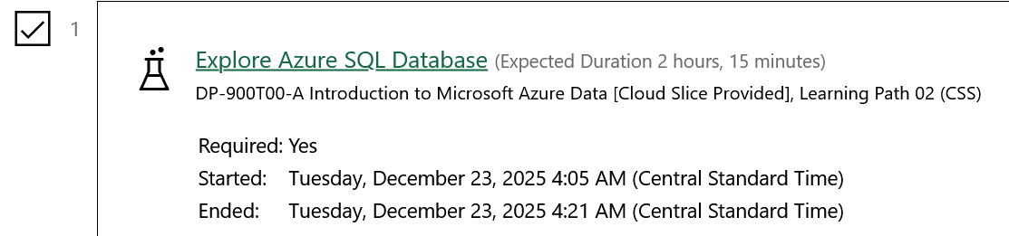

Day 3: Task 2

Please complete the below lab (4) ‘Explore non-relational data in Azure’ and paste evidence of the completed lab in the box provided.



Completed lab | 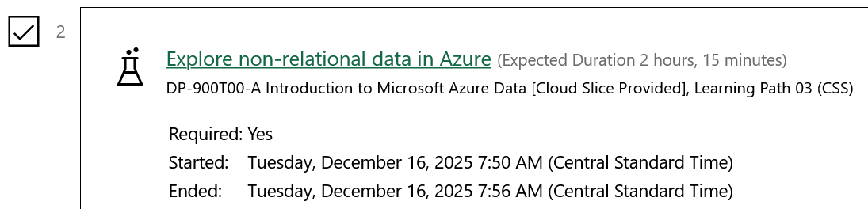

Day 3: Task 3

Please complete the below lab (5) ‘Explore data analytics in Azure’ and paste evidence of the completed lab in the box provided.

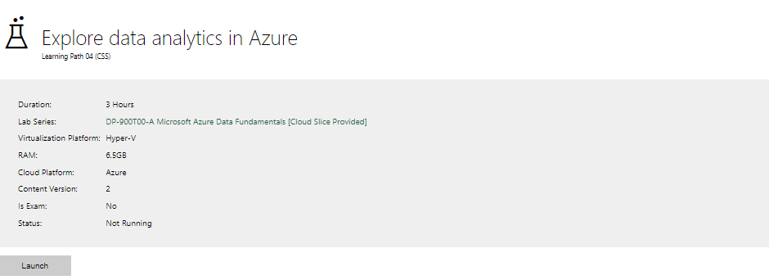

Completed lab | 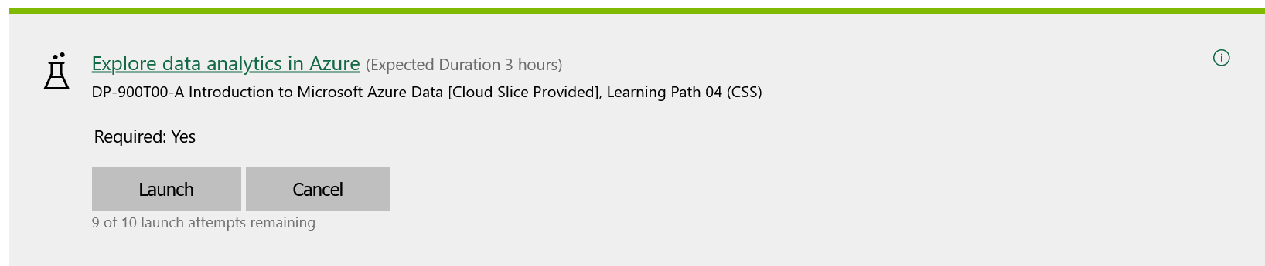

Day 4: Task 1

In your teams, complete the Azure DP-900 practice exam and paste your result below – this is open book and please research and discuss your answers as a team.


Result | Froze on compiling results:  

Day 4: Task 2

1. Scenario Background
"Paws & Whiskers" is a growing pet shop that aims to improve its business by analysing sales, customer information, and inventory data. Currently, the data is collected manually or stored in spreadsheets. Management is interested in transitioning to Microsoft Azure to streamline data storage, analysis, and reporting, enabling them to make data-driven decisions.

2. Data Laws and Regulations
Identify and explain the data laws and regulations relevant to handling customer data within the proposal. Ensure you cover the following points:
- GDPR Compliance: Highlight the importance of adhering to the General Data Protection Regulation (GDPR), particularly as it relates to storing and processing customer information.
- Data Protection Act (DPA) 2018: Outline how the DPA 2018 may affect the way "Paws & Whiskers" collects and stores data, ensuring compliance with UK laws on data privacy.
- Other Industry Standards: Research any additional data protection standards or regulations that may apply to pet shop data, particularly if they involve sensitive or payment information.

3. Azure Service Recommendations
Recommend Microsoft Azure services that would suit the company’s data analysis needs and explain why these services are suitable. Your recommendations should include:
- Data Storage: Identify suitable storage options, such as Azure Blob Storage or Azure SQL Database, and discuss the benefits of each for storing large datasets, including inventory, sales transactions, and customer details.
- Data Analysis Tools: Recommend tools such as Azure Machine Learning for customer behaviour analysis or Azure Synapse Analytics for analysing sales trends.
- Data Integration and Automation: Explain how services like Azure Data Factory could automate data collection and integration processes, improving efficiency.

4. Data Types and Data Modelling
Define the types of data "Paws & Whiskers" will need to work with and describe your approach to data modelling:
- Data Categories: Identify key data types, such as customer demographics, transaction history, pet inventory, and product categories.
- Data Modelling Approach: Outline how you would structure this data using a relational model or a data warehouse approach, considering factors like tables, entities, relationships, and primary keys.

5. Data Storage Formats and Structures in Azure
Discuss how you would store data within Azure and the formats you would recommend:
- Data Formats: Specify recommended formats (e.g., CSV for raw data imports, JSON for structured data, Parquet for analytics) and explain why these formats are suitable for specific data types.
- Data Security and Encryption: Include recommendations for securing data using Azure’s built-in encryption features and access controls to ensure compliance with data privacy regulations.

6. Additional Considerations
Provide any other considerations that might enhance data handling and efficiency in Azure, such as:
- Backup and Disaster Recovery: Outline a backup plan using Azure Backup or Azure Site Recovery to safeguard against data loss.
- Data Visualisation: Discuss potential use of Power BI within Azure for creating dashboards that provide management with real-time insights into sales and customer trends.
- Future Scalability: Comment on how Azure services can scale as the business grows, accommodating larger datasets and more complex analyses.

Submission Guidelines:
- Structure: Ensure your report is well-organised, with sections for each task (e.g., Data Laws, Azure Services, Data Types, etc.).
- Formatting: Include headings, bullet points where appropriate, and any visuals or diagrams that support your explanations.
- References: Cite any resources or regulations referenced in the report.
- Length: Aim for 1500-2000 words.

Course Notes

It is recommended to take notes from the course, use the space below to do so, or use the revision guide shared with the class:

Additional Information

We have included a range of additional links to further resources and information that you may find useful, these can be found within your revision guide.

END OF WORKBOOK

Please check through your work thoroughly before submitting and update the table of contents if required.

Please send your completed work booklet to your trainer.

